Curriculum Vitae of

Prof. M. Aslam

Current Assignment : Currently Vice-Chancellor, Indira Gandhi National Open University (IGNOU, New Delhi). Prior to the current assignments, he has served as Professor, School of Continuing Education, IGNOU since May, 1992 and served as Director , National Centre for Innovations in Distance Education, IGNOU, New Delhi from Dec, 2006-Feb., 2009 and also earlier as Director(Dean) SOCE, IGNOU, New Delhi from May 1998-May, 2001 and from January 2009- October 2011.
Areas of Interest : Prof. M. Aslam has rich and varied experience both at national and international levels in University Administration; Rural Development; ICT, Communication and Extension; Distance & Continuing Education; Multi-Media in Distance Eduction; Training Methodology; Training skills; Monitoring and Evaluation; Panchayati Raj and Social Change from his 33 years career in the field, out of which he spent about 8 years abroad on an international assignment.

Academic Career: Dr. Aslam has passed M.A. in Sociology with First Division and Second Position (1973), AMU, He got his M.Phil. in 1975 and Ph.D. (Sociology) in 1978.
Awards:
- As a Project Director, Panchayati Raj Project, developed a Multi-Media Distance Education package for Panchayati Raj Functionaries elected throughout the country. The package was introduced among 58,000 elected functionaries of Panchayats in 4 selected districts of Madhya Pradesh. This multi-media package has been conferred COL President’s Award of Excellence at PAN Commonwealth Forum in March,1999.
COL Award
- Prof. Aslam completed an ADB/Price Waterhouse Project on “Strengthening Local Self-Govt. in Madhya Pradesh”. A video programme produced under this Project “On the Threshold of 21stCentury” won SONY International Award (1999) in Japan.
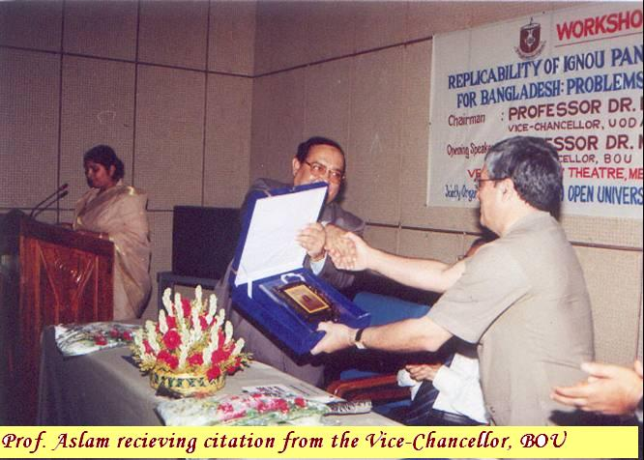
- Bangladesh Open University honoured Prof. Aslam in June, 2004 for successful completion of Panchayati Raj Project in India and its proposed replication in Bangladesh.
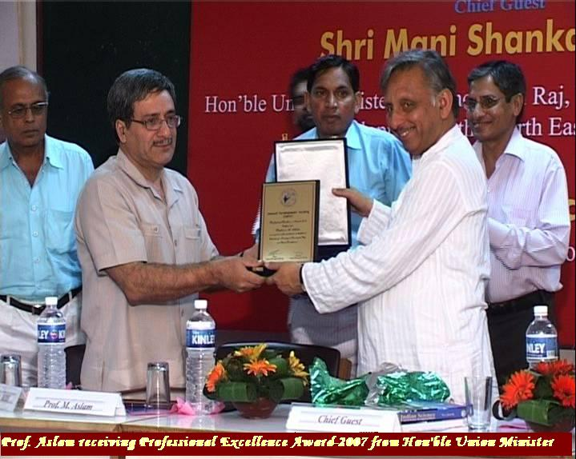
- Prof. Aslam was conferred, ‘ Professional Excellence Award’
Of Mewat Development Society by the Union Minister for Panchayats, in August, 2007.
- Prof. Aslam has been the ‘Project Leader’ for IGNOU-MOPR-UNDP project on ‘Capacity Building of PRIs through a Multi-Mode Training Intervention’ for implementing in six states namely Bihar, Haryana, Madhya Pradesh, Rajasthan, Chhattisgarh and Uttrakhand with the Indira Gandhi National Open University (IGNOU) as the implementing agency.
- Professor Aslam has also been the Hony. Chairman, Advisory Board, Rajiv Rural Development Foundation, Tirupati, Andhra Pradesh

Policy Work:
 Professor Aslam served as a UN expert to the ‘International Seminar on Rural Development: Policies, Strategies and Institutions’ organized by ‘ United Nations Economic and Social Commission for Western Asia’ in Beirut, Lebanon from December 20-22, 2004.

 Served as a member of the international group to prepare , ‘ The Global Strategic Plan for Democracy Education’ during , ‘The Pocantico Conference on Democracy Education’ organized by ‘the Council for the Community of Democracies & The American Forum for Global Education, June,2003, New York. Also chaired Asian Group during the meeting

 Served as Resource Person and Panelist for ‘Global Solidarity for Strengthening and Expanding Democracy.’ held in Seoul, Korea on November 10-12, 2002, attended by 100 Foreign Ministers.

 He served as Chairpersom, Academic Committee of National Institute of Public Cooperation & Child Development (NIPCCD), New Delhi (2002) and was subsequently responsible to undertake organizational & SWOT analysis of NIPCCD .

 Prof. Aslam served as a member of the working Group on Communication Strategies constituted by the Union Public Service Commission under Civil Service Review Committee in 2001

 Prof. Aslam also served as member of the working group on Decentralised Planning and Training constituted by the Ministry of Rural Development for formulation of 10th Five Year plan, Govt. of India.

- He was also member of the Media Advisory Committee of the Ministry of Rural Development, Govt. of India in 1999.

 As Director (Training) at CIRDAP the main responsibility of Prof. M. Aslam among others included to advise national institutions in member countries on matters related to training for rural development.

International
Training
Experience : Dr. Aslam served as Director, (Training) at the Centre on Integrated Rural Development for Asia and the Pacific (CIRDAP) based in Dhaka for about 8 years between 1981-88. CIRDAP is a regional, inter-governmental and international organisation established in 1979 by the countries of the Asia-Pacific region at the initiative of the FAO of the United Nations and with support from other UN bodies and donors. It has 14 members. These are Afghanistan, Bangladesh (host state) Burma, India, Indonesia, Lao PDR, Malaysia, Myanmar Nepal, Pakistan, Phillippines, Sri Lanka Thailand & Vietnam Dr. Aslam planned, designed and directed twenty one international training courses, workshops, seminars and consultations at CIRDAP between 1981-88 involving up to fifteen countries of Asia- Pacific region

International Research
Experience: Apart from dozens of national research projects Dr. Aslam planned, initiated, directed and supervised following international research/action research projects of CIRDAP:

i) Integration of Women in Agriculture and Rural Development. Bangladesh, India) at CIRDAP, 1981-82
ii) Case Studies : Participatory Field Workshop Approach.(Bangladesh, Nepal, Philippines and Thailand).at CIRDAP, 1984-86

iii) Community Participation in IRD through Community Information and Planning System (CIPS). (Bangladesh, Indonesia, Lao PDR, Malaysia, Nepal, Pakistan, Philippines, Sri Lanka, Thailand and Vietnam).,1984-87

Consultancy
Experience : He served as consultant/Expert to : FAO and UNDP of the United Nations; EDI of the World Bank; Commonwealth Advisory Services, Inc, Phillipine; NISTADS; UNESCO; ADB/Price Waterhouse; AARRO; UPSC; ESCWA of the United Nations; Commonwealth of learning and others.

Fellowship & Dr. Aslam is Fellow of the Economic Development Institute of the
Mission World Bank, Washington D.C. 1986.

- As one of the two members of EDI (World Bank) Study Mission in February and March,1988, Dr. Aslam Visited following organisations/institutions in various countries of Europe and Latin America, established professional contacts with these institutions, identified areas of mutual interest and explored possibilities for future collaboration including funding for identified activities. These included:

Sweden : Swedish International Development Authority (SIDA)
Germany : Ministry of Economic Cooperation (BMZ)
German Technical Cooperation (GTZ)
German Agro-action
U.S.A. : United Nations Development Programme (UNDP)
United Nations Fund for Population Activities (UNFPA)

UNICEF
United Nations Development Fund for Women (UNITAR)
Ford Foundation
International Food Policy Research Institute (IFPRI)
EDI of the World Bank
Canada : International Development Research Centre (IRDC)
Canadian University Services Overseas (CUSO)
Costa Rica : Inter-American Institute for Cooperation in Agriculture
(IICA) , Tropical Agriculture Research and Training Centre
(CATIE)

Memorandum of
Understanding : Dr. Aslam was responsible :
- For initiating, developing and implementing `Memorandum of Understanding ‘signed between EDI of the World Bank and CIRDAP for conducting joint training activities in rural development for Asia-Pacific region in 1986.
- As member of CIRDAP study mission to Inter-American Institute for Cooperation in Agriculture (IICA) in Costa Rica to develop `Memorandum of Understanding' signed between IICA and CIRDAP in 1988.
- For initiating & developing `Memorandum of Understanding' signed between IGNOU and NIRD for Colloborating in rural development activities in 1993.
- For initiating & developing, ‘Memorandum of Understanding' signed between IGNOU and seven State Open Universities for implementing Panchayati Raj Project activities in their respective states.
Publications :
- Books :
Among the books published or jointly authored by Dr.Aslam include:
- ‘Panchayat Raj in India’ – National Book Trust of India
New Delhi , 2007
- “Directory of Panchayati Raj Training Institutions in India”,
Compiled for Task Force on Panchayati Raj, Rajiv Gandhi
Foundation, New Delhi, January, 2001
- “Revitalization of Panchayati Raj in India - Problems &
Prospects”for Task Force on Panchayati Raj, Rajiv
Gandhi Foundation, New Delhi – 1997.
- `Integrated Rural Development in Asia - Concept, Practice
and Perspective' Manohar Publishers, New Delhi - 1993.
- `Manual for Training of IRD Functionaries: Planning; Management,and Methodology'.CIRDAP, November, 1987.
- `Organizing Rural Poor: Guidelines for Training' with G.C. Clark (based on the Experiences of CIRDAP Member Countries). CIRDAP 1986.
- `Guidelines on Organizing Participatory Field Workshops' with G.C.Clark (based on 10 country experiences),CIRDAP,September 1987.
- `Economic and Social Impact of Development Programmes' (A study of 30 villages in Hissar, Haryana) with Prof. J. S. Mathur and Dr. P.T.George, NIRD, 1981.
- `Social Implications of Technological Changes in Rural
Kashmir', Inter-India Publications, New Delhi, 1981.

- Reports/Publications:
Supervised, Contributed and finalized following reports & publications:
- Hardware Mapping- A Concise Report ( based on 6 state specific studies) IGNOU-MOPR-UNDP project on capacity Building of PRIs-A Multi Mode Trg. Intervention, IGNOU, November, 2009 ( Co-authored With Dr Anil Wali, IIT . Delhi)
- ‘State Development Report on J&K’ sponsored by the Planning Commission, Govt. of India through Institute of Social Sciences, New Delhi- 2003
- “Strengthening of Panchayati Raj System- A Training Intervention” A Survey”. Task Force on Panchayati Raj, Rajiv Gandhi Foundation, New Delhi January, 2001
- Multi-media Package on Panchayati Raj- A distance education training package consisting of 23 booklets, 6 video and 12 audio programmes introduced among 58,000 elected members. It was also conferred Commonwealth of Learning President’s Award of Excellence in 1999.
- “Voices from Below – Summary Proceedings of Sub-Regional Workshops on Panchayats : Issues & Recommendations”, Rajiv Gandhi Foundation, New Delhi, Nov., 1997.
- `Monitoring and Evaluation, Arrangements and Techniques
in Rural Development', CIRDAP, June 1985.
- `People's Participation in Rural Development:An
Overview of South and Southeast Asian Countries'. CIRDAP,
March 1984.
- `Guidelines on IRD Plan Formulation, Implementation,
Monitoring and Evaluation',CIRDAP, October, 1983.
- Prepared about one dozen booklets in distance education
format under Panchayati Raj Project during 1994-2004.

- Reports (Mimeographed)
Dr..Aslam has twenty `National and International Reports' to his credit, which includes among others "Integrated Rural Development in China" prepared for FAO under author's Contract and “Training Report on Co-operative Supervisors and Cadres in Lao PDR.”

D. Papers Published & Presented

Dr. Aslam has presented as many as forty five papers in various seminars, conferences and workshops etc. Dr.Aslam has Published about two dozen papers in various journals in India and abroad which among others include four chapters on "Rural Development in Bhutan, China, Republic of Korea and Maldives in the “State of Art on IRD" published by CIRDAP in 1987and ‘Training for Rural Development Professionals through Distance Mode’ in the Indian Journal of Open Learning.
One of his papers on “Training Millions – Pedagogical Challenges for Distance Education” was published in “Open Learning” Vol. 15 No.3, 2000 , of UK Open University.

Book Chapters: i). ‘Training non-formal, community and adult educators’ a book chapter co-authored with Prof. Charles Potter, in ‘Teacher Education Through Open and Distance Learning’ Edited by B. Robinson & Colin Latchem. (World Review of distance education and open learning:Vol.3) COL & Routledge/Falmer, , London/New York.-2003
- ‘Education and Training for Rural Development Through Distance Mode- A South-Asian Perspective’ in Decentralisation and Local Governance edited by L.C. Jain, published by Orient Longman Ltd.- 2005
- ‘Local Self-Govt. in India- A Retrospect & Prospect’ in Fedral India – A Design for Good Governance-Manak Publications New Delhi 2005
- ‘Application of ODL Methodologies in Non-formal Settings and Quality Assurance: A Case Study from the Indira Gandhi National Open University, New Delhi ‘ in ‘Quality Assurance in Distance Education: Towards a Culture of Quality- COL 2006

Visiting Faculty
- Dr. Aslam served as visiting faculty to as many as 16 institutions in India and abroad
Membership:
- Life Member, Indian Sociological Association
- Life Member, Indian Institute of Public Administration, India.
- Member, Bangladesh Society for Training and Development (1981- 88)
- Member, Association of Development Research and Training Institute of Asia and Pacific (ADIPA),Malaysia. (1986-2005)
- Ex-Officio Member School Board, School of Continuing Education, IGNOU ( 1992-2011)
- Member, School Board, School of Education, IGNOU (April 1998 – 2000)
- Member, Extension Council, IGNOU (1996-98).
- Member, Task Force on Panchayati Raj, Rajiv Gandhi, Foundation (1994-2003)
- Member, International Rural Network, England (2006-2007)
- Member, Asian Rural Sociology Working Group.Japan.(1999-2002)
- Member, Academic Council, IGNOU
- Member, Media Advisory Committee, MORD, Govt. of India (
1999)
- Member/Chairmen, Academic Committee,NIPCCD, New Delhi
(2000-02)
- Member, Working Group on Communication Strategy, UPSC 2000-
2001
- Hony. Chairman, Advisory Board, Rajiv Gandhi R.D..Foundation,
Tirupati (AP). ((2006-2008)
• Member, IT Expert Committee, Ministry of Panchayati Raj, Govt. of India (2007-2008).
- Member, Central Advisory Committee, Ministry of Panchayati Raj,
Govt. of Ondia ( 2006- 2009)
- Chairperson, Member School Board, School of Continuing Education, IGNOU (1998-2001 and 2009- 2011)

Countries Visited: Bangladesh, Botswana, Canada, China, Costa Rica, England, Federal Republic of Germany, France, Holland, Hong Kong, Indonesia, Iraq, Italy, Korea, Kuwait, Lao PDR, Lebanon, Malaysia, Nepal, Pakistan, Philippines, Saudi Arabia, South Africa, Singapore, Sri Lanka, Sweden, Thailand, United Arab Emirates, USA and Vietnam.

Personal Information:
Professor M. Aslam
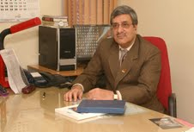
Vice-Chancellor
Indira Gandhi National Open University
Maidan Garhi
New Delhi - 110 068.
Phones: Office (011) 29532707 ,Fax: (011) 29535933
E.Mail: vc@ignou.ac.in ; vco@ignou.ac.in

